**Term-work 3**

**Complete problem definition of the Term-work**

**Write** a Java program to simulate LOST UPDATE or INCONSISTENT READ Transaction issues of database using MULTITHREADING features of JAVA.

Also write a java program to control the above concurrency issue. Output of the program to be displayed on the screen as well as to be written in a file of user choice.

**Expected Learning**: Multithreading and Streams of java language

**Source code/Program**

/*

* To change this license header, choose License Headers in Project Properties.

* To change this template file, choose Tools | Templates

* and open the template in the editor.

*/

/**

*

* @author kishan

*/

import java.sql.Connection;

import java.sql.DriverManager;

import java.sql.ResultSet;

import java.sql.SQLException;

import java.sql.Statement;

class PrintJob implements Runnable {

@Override

public void run(){

Connection con;

Statement st;

ResultSet rs;

try{

Class.forName("com.mysql.jdbc.Driver");

String url = "jdbc:mysql://localhost:3306/studentdb";

con = DriverManager.getConnection(url,"root","");

st = con.createStatement();

System.out.println("Before Update");

String query = "select * from result" ;

rs = st.executeQuery(query);

System.out.println("Records of database:");

while(rs.next())

System.out.println(rs.getString(1)+" "+rs.getString(2));

con.close();

}

catch(ClassNotFoundException | SQLException e) {

System.out.println("Error"+e);

}

}

}

class UpdateJob implements Runnable {

@Override

public void run(){

Connection con;

Statement st;

int rs;

ResultSet rs1;

try{

Class.forName("com.mysql.jdbc.Driver");

String url = "jdbc:mysql://localhost:3306/studentdb";

con = DriverManager.getConnection(url,"root","");

st = con.createStatement();

String query = "UPDATE result " +

"SET Grade = 'S' WHERE Name='sk'";

rs = st.executeUpdate(query);

System.out.println("After update");

String query1 = "select * from result" ;

rs1 = st.executeQuery(query1);

System.out.println("Records of database:");

while(rs1.next())

System.out.println(rs1.getString(1)+" "+rs1.getString(2));

con.close();

}

catch(ClassNotFoundException | SQLException e) {

System.out.println("Error"+e);

}

}

}

public class LostUpdate {

public static void main(String[] args) {

PrintJob pj= new PrintJob();

UpdateJob uj= new UpdateJob();

Thread a = new Thread(pj);

Thread b = new Thread(uj);

a.start();

b.start();

}

}

**Output with Screenshot**

//Inserted row with name ‘sk’

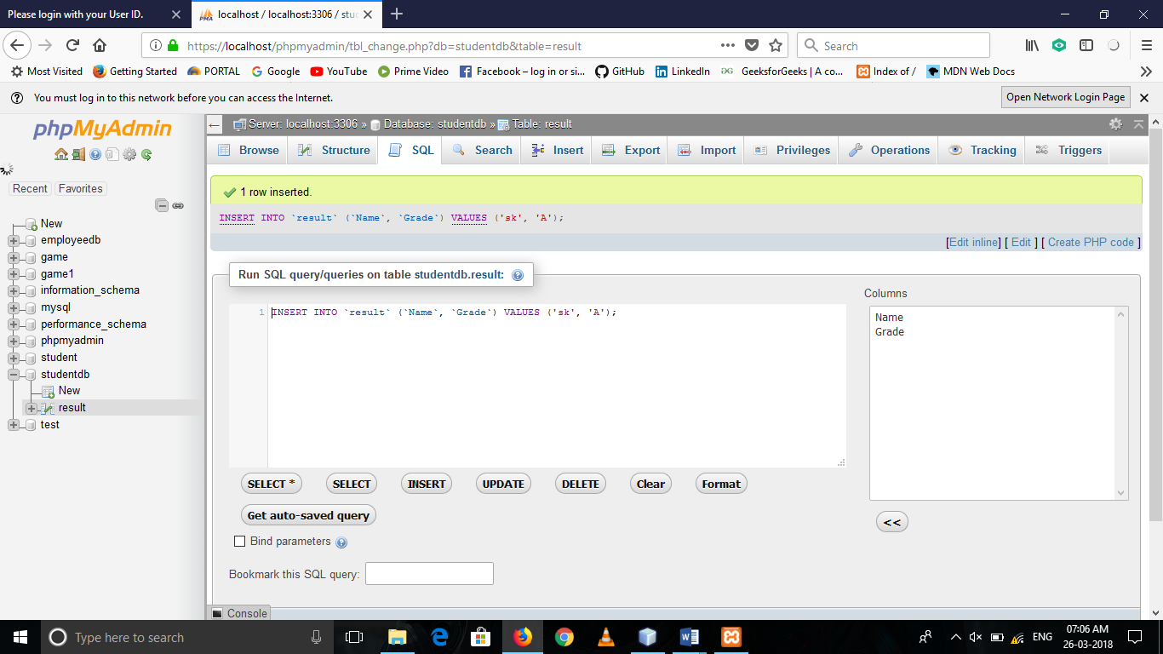

//Output on Console

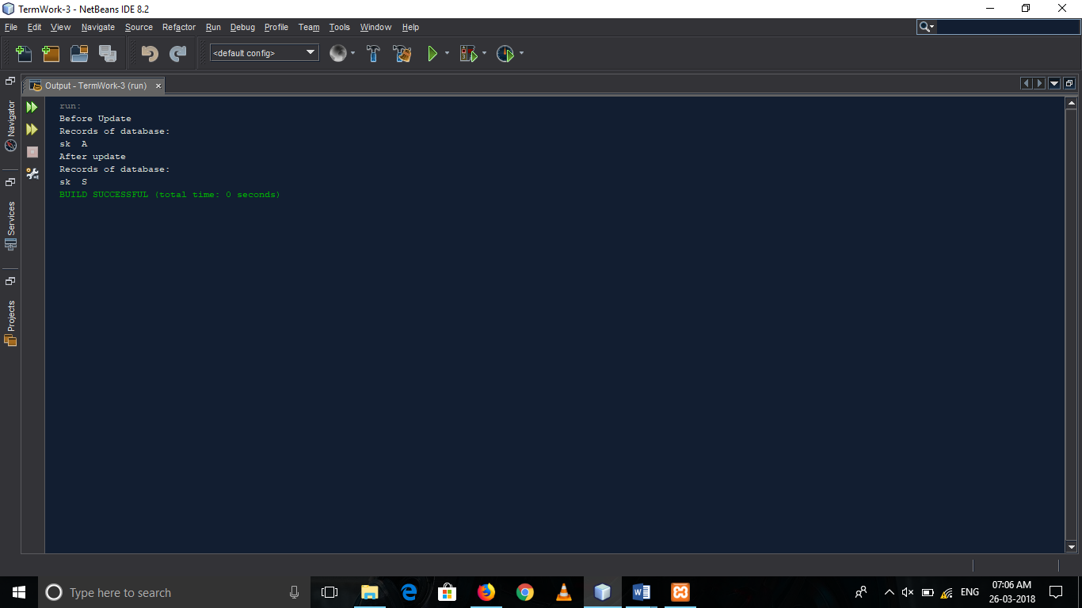

//Output in database

